**The Battle of Neighborhoods (Week 1) – A Capstone Project**

**Problem Statement:** What are the possible locations for someone to open a Turkish restaurant in Bucharest.

**1.Introduction**

**1.1 Background**

Bucharest is the capital and largest city of Romania, as well as it’s cultural, financial and industrial centre. It is in the southeast of the country, at [44°25′57″N  26°06′14″E](https://geohack.toolforge.org/geohack.php?pagename=Bucharest&params=44_25_57_N_26_06_14_E_scale:100000), on the banks of the Dambovita River, less than 60 km (37.3 mi) north of the [Danube River](https://en.wikipedia.org/wiki/Danube) and the [Bulgarian](https://en.wikipedia.org/wiki/Bulgaria) border.

Economically, Bucharest is the most prosperous city in Romania. The city has a number of large convention facilities, educational institutes, cultural venues, traditional 'shopping arcades' and recreational areas.

The city proper is administratively known as the 'Municipality of Bucharest' and has the same administrative level as that of a national [county](https://en.wikipedia.org/wiki/Counties_of_Romania), being further subdivided into six [sectors](https://en.wikipedia.org/wiki/Sectors_of_Bucharest), each governed by a local mayor.

Bucharest has 2 million populations and consists of 6 sectors. Neighborhoods and populations in sectors are as below:

* Sector 1 (population 227,717): Dorobanți, Băneasa, Aviației, Pipera, Primăverii, Dămăroaia, Grivița
* Sector 2 (population 357,338): Pantelimon, Colentina, Iancului, Tei, Floreasca, Moșilor, Obor, Fundeni,
* Sector 3 (population 399,231): Vitan, Dudești, Titan, Centrul Civic, Dristor, Lipscani
* Sector 4 (population 300,331): Berceni, Olteniței, Progresul, Văcărești, Tineretului
* Sector 5 (population 288,690): Rahova, Ferentari, Giurgiului, Cotroceni, 13 Septembrie, Dealul Spirii
* Sector 6 (population 371,060): Giulești, Crângași, Drumul Taberei, Militari, Grozăvești (Regie), Ghencea

As stated by the Mercer international surveys for quality of life in 231 cities around the world, Bucharest occupied the 109th place in 2019. Bucharest, at number 109, ranks low in the European list but better than other European cities such as Sofia (116th) and Belgrade (139th).

Many neighborhoods, particularly in the southern part of the city, lack sufficient green space, are formed of cramped high density block of flats. This may affect people’s life as well.

**1.2 Problem Explanation**

In this project, I will explore the different neighborhoods of Bucharest and will investigate which area would be good for someone to open a Turkish Restaurant.

**1.3 Why it is of Interest**

Any budding entrepreneur would find this project interesting so that they may change the location details if they want to and do the analysis for the interested area.

**2. Data**

**2.1 Data Sources**

In order to solve the problem, I will get the required data from various data sources as mentioned below:

* I will get the neighborhood data of Bucharest from Wikipedia
* I will use python geocoder library to get geographical coordinates of neighborhoods.
* I will use **Foursquare API** **venues explore** method to get the venues of given neighborhoods of Bucharest.
* I will use **Foursquare API venues method** to get ranks and likes of restaurants by given venue id.

**2.2 Feature Selection and Data Usage**

I will use neighborhood location values to analyze Bucharest geographical structure. I will use folium library of python to draw maps by using given latitude and longitudes of neighborhoods.

I will use the data of populations of neighborhoods who has big population to check if they may need a new restaurant.

I will also classify neighborhoods by using venues distribution and counts. In this way, I will find similarities of neighborhoods which will help me to choose location for opening a new restaurant. Similar structured neighborhoods may handle same type of venue.

I will use venue list category to find distribution of restaurants and Turkish restaurants in neighborhoods.

I will use also ratings and likes of restaurants in the areas. It may help me to find location with bad rating restaurants which may need a new restaurant.

**3. Methodology**

* I used GitHub repository for code versioning.
* The Bucharest data is available with the neighborhood name in Wikipedia. Location information (latitude and longitude) of neighborhoods is taken from geocoder library.
* I took neighborhood from Wikipedia and put blue dots on Bucharest map to see centers of neighborhoods. There are **40** neighborhoods in Bucharest.

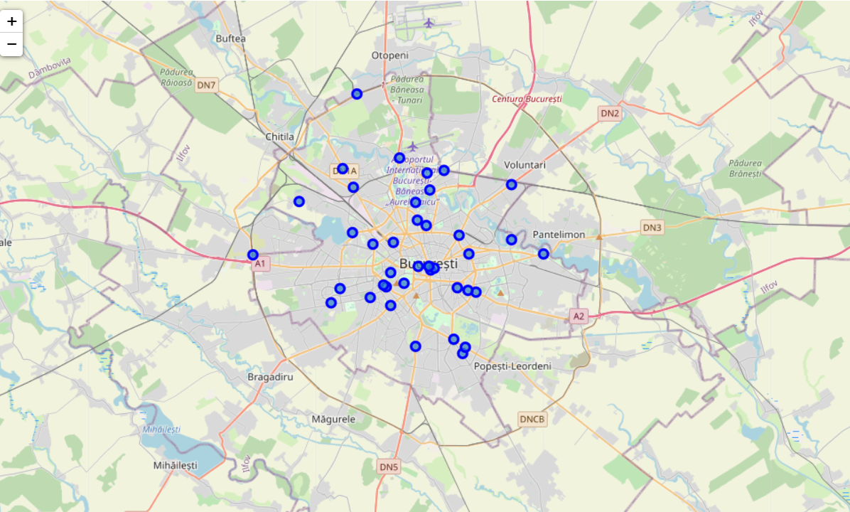

* I also got sector names of neighborhoods and populations of sectors. There are 6 sectors in Bucharest. I also merged Sector and Neighborhood data to see in which sector neighborhood places.

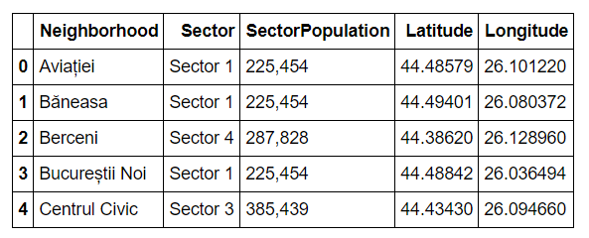

* By using Foursquare API, I got venue list with 1 km distance to neighborhood's center.

There are 215 unique venue categories

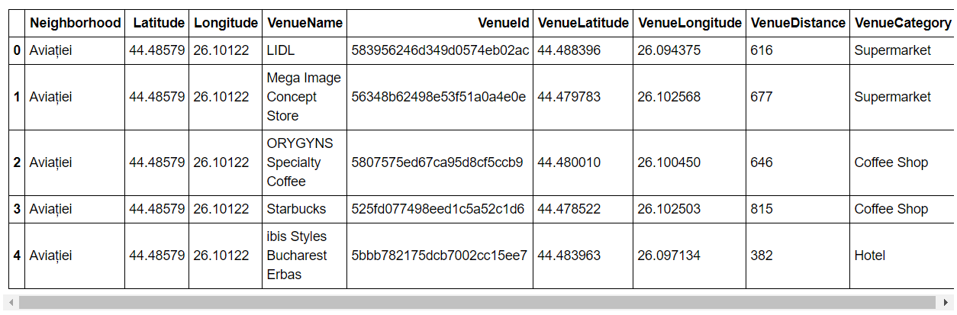

* I filtered all other restaurants to get Turkish restaurant. We can see from histogram of restaurants that 20 neighborhoods do not have any Turkish restaurant.

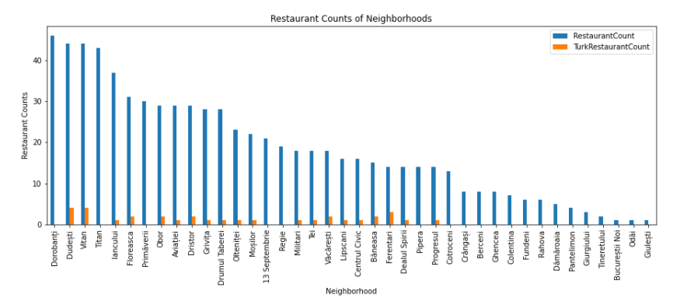

* I used foursquare to get restaurant ratings by using venue id and merged with venue data

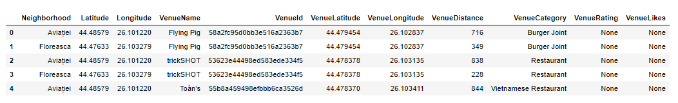

* I created a heatmap for counts of restaurants in neighborhoods by using Folium library. On heatmap, I used 4 few circles indicating distance of 2km, 4km, 6km and 10km from Bucharest center.

I superimposed the existing blue dots with red markers for Turkish Restaurants and **blue** circles for Turkish restaurants with rating less than 7 on first map.

I superimposed neighborhoods **without any Turkish** restaurant with **cyan** markers in second heatmap.

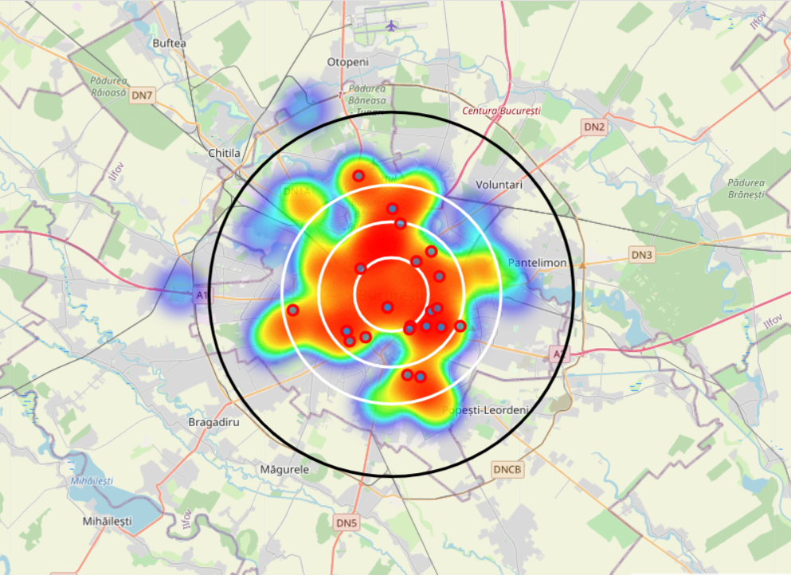 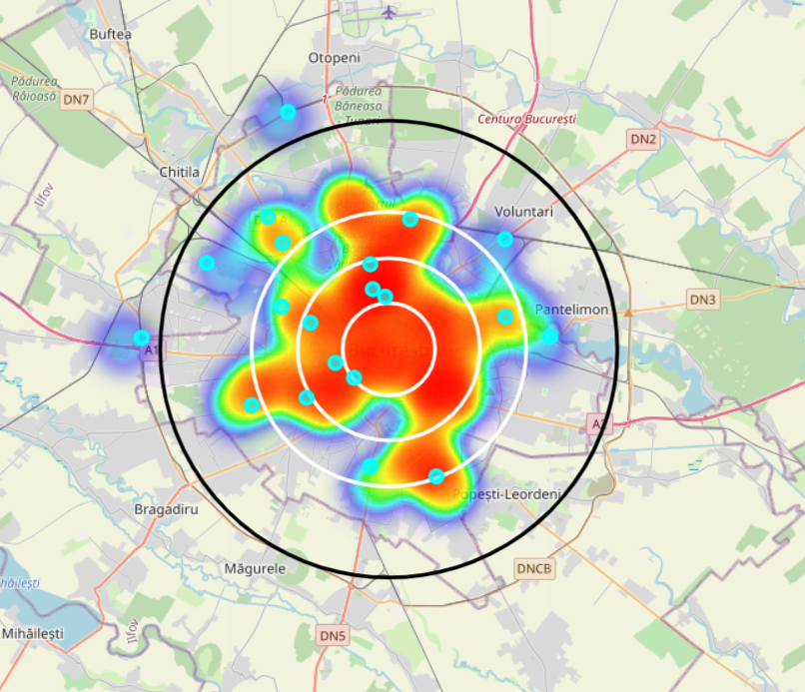

* I used Agglomerative Clustering to cluster neighborhoods according to count of venue categories in each neighborhood. According to the below graph, I decided to separate our neighborhoods into 6 clusters (cut at distance of 20, horizontal black line).

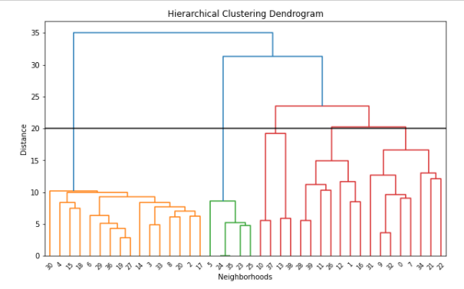

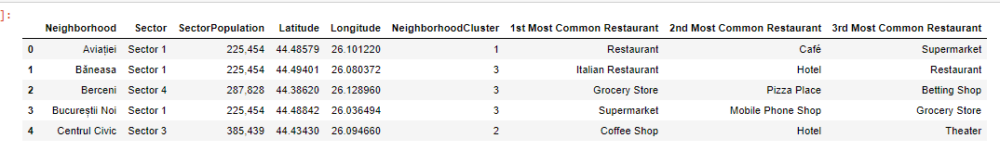

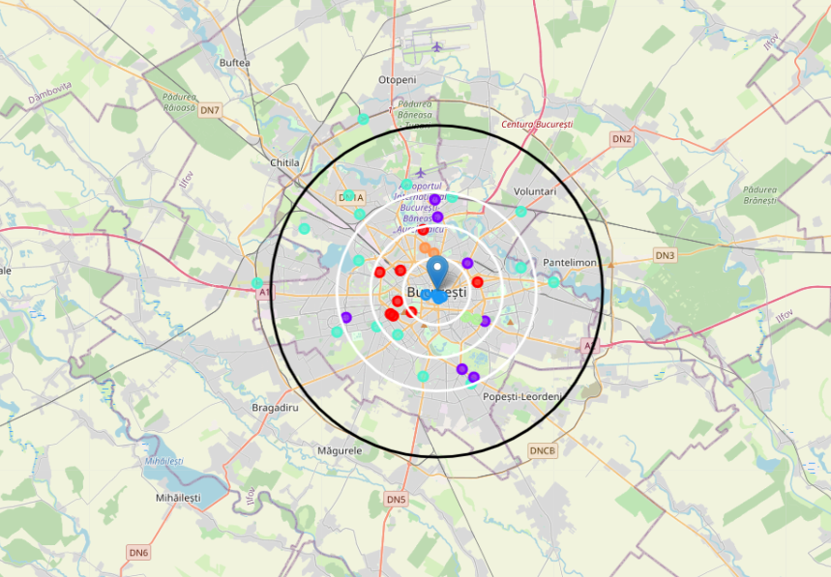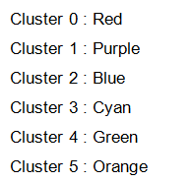

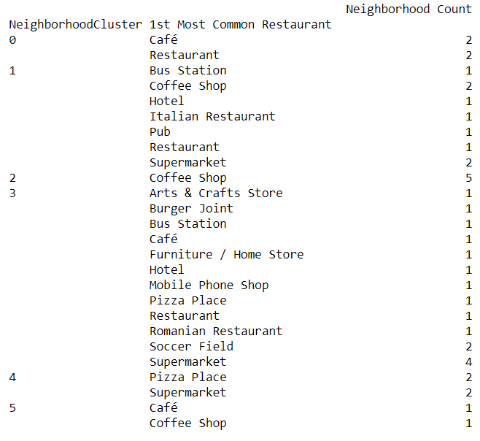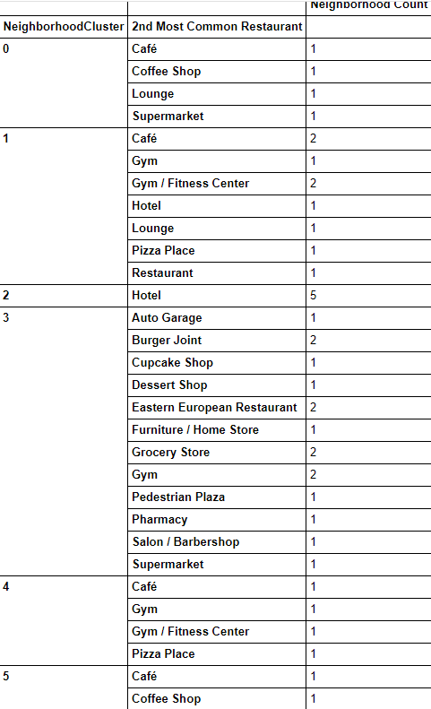

By observing above results we can broadly divide cluster categories as below:

Cluster 0 (Red) : Café, Lounge and Supermarket, Restaurant

Cluster 1 (Purple) : Café , Gym, Hotel, Pizza, Bus Station, Pub, Restaurant

Cluster 2 (Blue) : Hotel, Coffee Shop

Cluster 3 (Cyan) : Supermarket/Furniture/Arts&Crafts Stores, Gym, Salons, Pharmacy,Deserts/Burger/East European joints, Bus Station, Café, Soccer Field, Romanian Restaurant

Cluster 4 (Green) : Café, Gym, Pizza, Supermarket

Cluster 5 (Orange) : Café/Coffee shop

**4. Results**

I investigated that Turkish restaurant counts in Bucharest is 4.68%

Total number of restaurants: 470

Total number of Turkish restaurants: 22

From bar chart, I observed that

* Dorobanti is the neihgborhood having high number of restaurants, but has very less Turkish restaurants.
* Dudesti is also having the high number of restaurants , but there is not even single Turkish restaurant.
* Giulesti and Odai are the neihgborhoods having least number of restaurants.
* 20 neihgborhoods do not have any Turkish restaurant. we can choose one of these to open restaurant

From heat maps, we can see that there are

* Many restaurants in 4 km radius from the center
* Good amount of restaurants between 4-6 km from the center
* Not many restaurants after 6 km
* Turkish restaurants are represented with red superimposed on blue dots. Blue dots are Turkish restaurant with rating <7
* Turkish restaurants are located in South, North , East, between 2-4 Km distance around center
* There are no Turkish Restaurants in West Part.
* Four Turkish restaurants got low ratings which means people does not prefer these restaurants too much and so there are high chances, if any Turkish restaurant opens there, may receive good profit.

**5. Discussion**

Clusters 0,2 and 5 appears to be having less commercial market.

Clusters 1,2 and 3 has one or the other kind of hotels.

Clusters 1,3 and 4 clusters have Italian Joints.

Cluster 3 appears to be crowded most of the times depending on the number of different kind of avenues there.

**6. Conclusion**

Possible Neighborhoods to set up a Turkish Restaurant:

**Neighborhood 1 (Crângași - Cluster 3 Sector 6 367,760):**

Cluster 3 would be the most suited place kept in mind the number of avenues available. However, competition will also be equal. Also Sector 6 one of top three highest populated sectors.

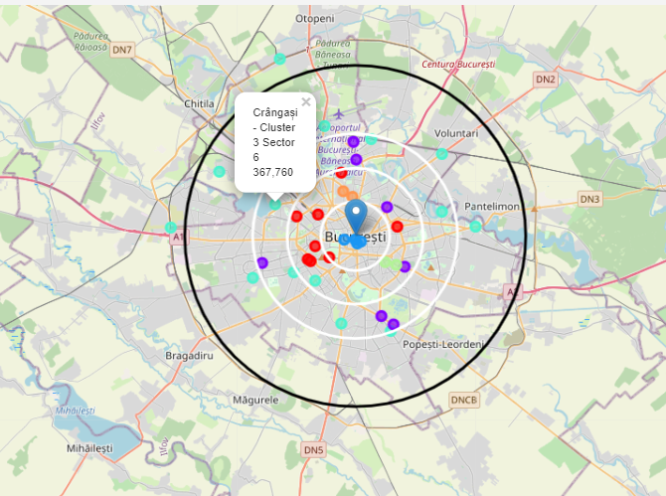

**Neighborhood 2 (Drumul Taberei - Cluster 1 Sector 6 367,760):**

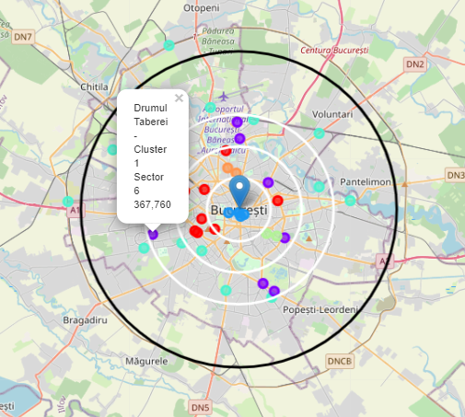

Drumul Taberei is located on the West side and also is a part of highest populated sectors in Bucharest. Cluster 1 also has less restaurants and bus station. Keeping all the above pointers in mind this can also be considered as a venture.

**Neighborhood 3 (Titan - Cluster 5 Sector 3 385,439):**

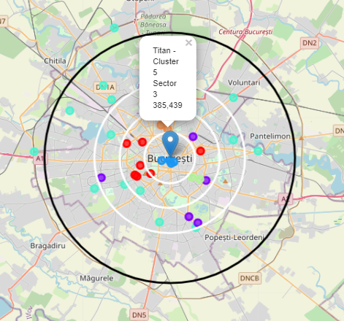

Titan is very near to the central western area and also is one of the highest populated sectors which means there is high demand and has no restaurants at all.

**Neighborhood 4 (Regie - Cluster 0 Sector 6 367,760):**

Regie is in the prime western location of Bucharest and is under the highest populated areas with very less avenues similar to Titan. So this place will also be a good place to start a Turkish restaurant.

